Technical Design Document for
Equipment Inventory Management Application
Devin Puckett & Justin Albecker
Grand Canyon University: CST-326
Milestone 3 Technical Design Document
Due Date: 10/11/2026

Introduction
The Equipment Inventory Management Application is a browser-based system designed to give small organizations one place to manage shared equipment. Instead of relying on spreadsheets, paper sign-out sheets, or trying to remember who has an item, the system keeps the information in one application. Employees will be able to view available equipment, search and filter the inventory, check items out and return them, request reservations, view their own checkout history and due dates, and report damaged equipment. Administrators will have additional tools to manage users and equipment, approve reservations, review damage reports, monitor overdue equipment, and view current inventory information from a dashboard.
This technical design document explains how the requirements from Milestone 2 will be implemented. The focus is on how the application will be organized behind the scenes, how information moves through the system, how the database will store the data, and how the main features will work. The goal is to give enough technical detail that the application can be developed without making the design more complicated than it needs to be.
Scope
This document covers the technical design for the Equipment Inventory Management Application as a full-stack web application backed by a relational database. The design includes authentication and role-based access for Employees and Administrators, equipment management, search and filtering, equipment checkout and return, reservations, checkout history, damage reporting, on-screen notifications, and the administrator dashboard.
The document also describes the layered architecture, server-side processing, database design, security controls, and the way the nonfunctional requirements will be tested. A mobile application, GPS tracking, barcode or RFID hardware, automated purchasing, financial accounting, enterprise reporting, and email notifications remain outside the scope of this project. Notifications will stay on-screen or printable, which keeps the project within the scope already established in Milestone 2.
Functional Description
The Equipment Inventory Management Application is a single web application with separate Employee and Administrator areas. Both areas run on the same server and database, and what a user can see and do depends on their role. The subsections that follow explain how the functional requirements from Milestone 2 will be built. They start with the system architecture and how users move through the application, then cover the client and server sides and the database design. After that, each major feature area is described in turn: equipment checkout and return, equipment management, account and user management, reservations, and damage reports and notifications. Background tasks, interfaces with other systems, and security are covered last, followed by how each nonfunctional requirement will be verified. The sections follow the same order as the Milestone 2 requirements document, and they refer to the related FR and NFR numbers where helpful, so each design decision can be traced back to the requirement and user story it supports.
System Architecture
The application will use the layered web architecture that was identified in the functional requirements document. Employees and Administrators will access the system through a modern web browser. Their requests will move through the controller layer, service or business logic layer, repository or data-access layer, and then to the relational database. Keeping these responsibilities separated should make the application easier to understand, test, and maintain as the project grows.
Browser and User Interface
The browser is the part of the system the user works with directly. It will display the login screen, equipment lists, forms, history pages, and administrator pages. The browser will send requests when a user logs in, searches for equipment, checks an item out, returns an item, or performs another action. It can provide basic client-side validation for a better user experience, but the server will still perform the final validation before any important data is changed.
Controller Layer
The controller layer will receive requests from the browser and direct them to the correct service. Controllers will stay focused on handling the request, checking the result, and deciding what page or response should be returned. The controllers will not contain the main business rules for checkout limits, reservations, equipment status, or other application logic.
Service / Business Logic Layer
The service layer will handle the main business rules for the application. This includes authentication and authorization checks, equipment checkout and return rules, due-date handling, reservation approval rules, damage reporting, status changes, overdue calculations, and notification creation. Keeping these rules in services will prevent the same logic from being repeated in multiple controllers.
Repository / Data Access Layer
The repository or data-access layer will handle communication with the relational database. It will be responsible for retrieving records, inserting new records, and updating existing records. Database operations will go through this layer instead of being written directly inside the user interface or controller code.
Relational Database
The relational database will store the long-term application data, including user accounts, equipment, categories, checkout records, reservations, damage reports, and notifications. Historical information will be preserved when a user is deactivated or an equipment item is retired so that past transactions do not disappear.
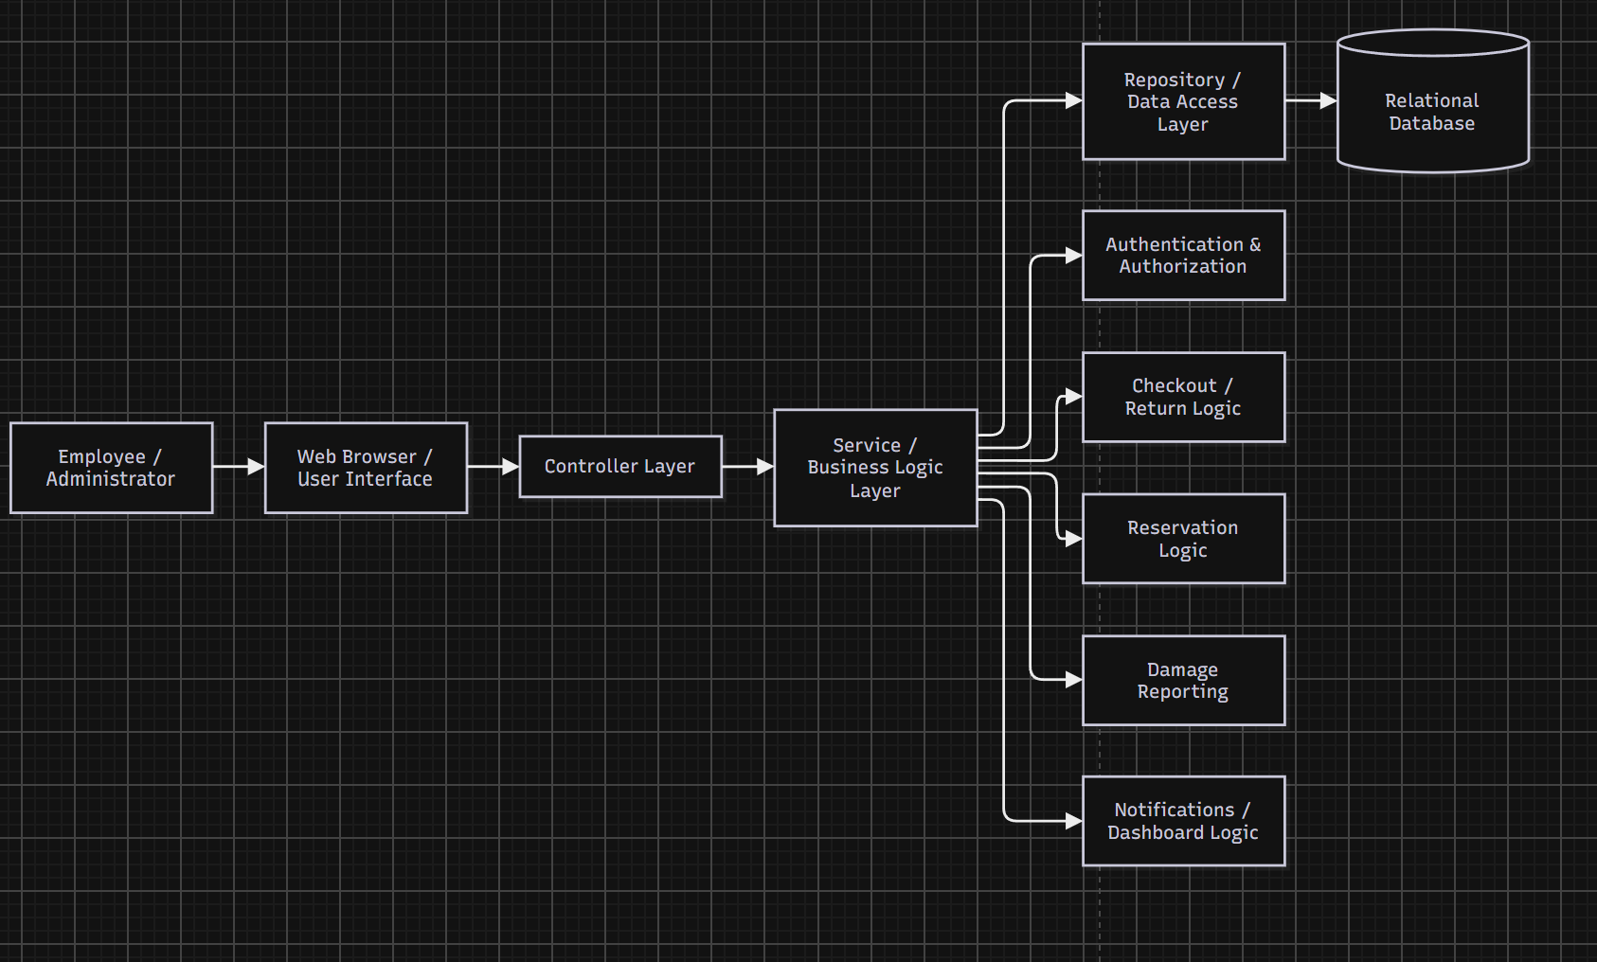Figure 1. Equipment Inventory Management Application Architecture

User Dialogs and Control Flow
Every user starts at the Login page. When valid credentials are submitted, the system checks the account's role and status before opening a session. Accounts with a Deactivated or Pending status are stopped at the Login page and shown the message that matches their status. If the account was given a temporary password by an Administrator, the user is sent to a Change Password page and must set a new password before reaching any other page. Otherwise, the user goes to a landing page based on their role. Employees land on the Equipment List, and Administrators land on the Dashboard.
Employees work mainly in the Equipment List. From there they can search and filter, then open an item's details page. The details page is where most Employee actions start: Check Out, Request Reservation, and Report Damage. A shared navigation bar links to My Equipment, Checkout History, and My Reservations. My Equipment holds the Return and Print actions.
Administrators have the same equipment pages, with Add, Edit, and Retire controls added. Their navigation bar also links to User Management, Categories, Reservations, Damage Reports, and the Overdue List. Selecting a count on the Dashboard opens the matching filtered list of items.
Every page has a Log Out option that ends the session and returns the user to the Login page. If the session times out after 30 minutes of inactivity, the user is also returned to the Login page.
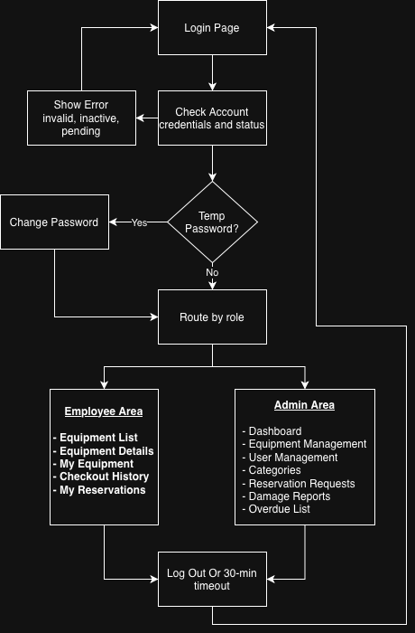
Figure 2. User Navigation and Control Flow
Client-Side Design
The client side is the set of pages rendered in the user's browser. The server generates each page with the data for the current user, so the browser does not hold any business rules. All pages share one layout: a header with the application name and the logged-in user's name, a role-based navigation bar, a message area for success, error, and notification banners, and the main content area. Navigation links and action buttons the user's role cannot use are not shown. As described in the Security Design section, the server still enforces these restrictions on every request.
Forms use labeled fields and mark required fields. They perform basic browser-side checks, such as required fields, email format, date order, and photo file type, so users get quick feedback. The server repeats every one of these checks before saving anything. Error messages appear beside the field that needs to be corrected.
Tables such as the Equipment List, My Equipment, Item History, and the Overdue List are paginated. On narrow screens, these tables scroll inside their own container so the page itself never needs horizontal scrolling. Overdue rows on My Equipment are highlighted and labeled "Overdue," so the status is not shown by color alone.
The Print view of My Equipment uses a print stylesheet that hides the navigation and buttons. It leaves only the list of checked-out items and their due dates. The site targets current versions of Chrome, Edge, and Firefox on desktop and stays usable at screen widths of 360 pixels and above.
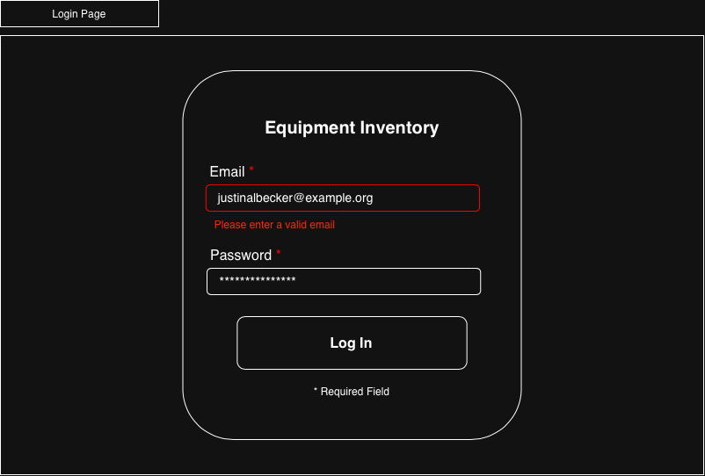
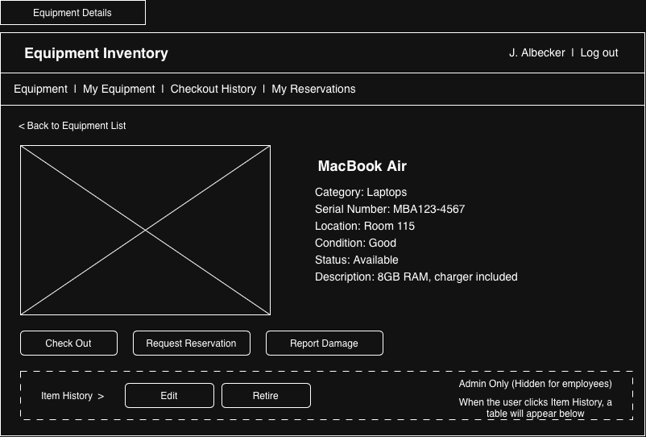
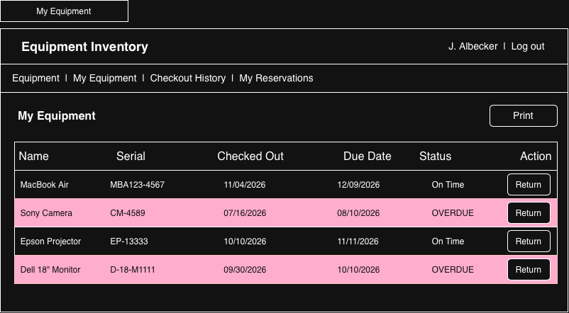
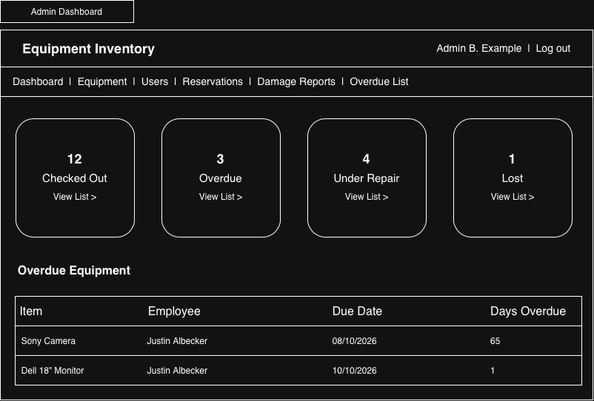

Figure 3. Main Application Wireframes
Note* Colors shown in the wireframes are placeholders. The final color scheme has not been chosen.
Server-Side Design
The server side will handle the work that should not be trusted to the browser alone. When a request is received, the server will identify the logged-in user, verify that the user has permission to perform the requested action, validate the submitted data, apply the related business rules, and then use the repository layer to read or update the database. This keeps important rules in one place and prevents users from bypassing them by changing a page in the browser.
Request Processing
A normal request will move from the browser to a controller and then to a service. The service will perform the required checks and call the appropriate repository methods. After the database operation is complete, the result will move back through the service and controller to the browser. If validation fails, the request will stop before the database is changed and a clear message will be shown to the user.
Validation and Business Rules
Server-side validation will be used for all important form data even if the browser also performs validation. Examples include checking for a valid and unique email address, requiring unique equipment serial numbers, limiting photo uploads to the allowed file types and size, validating reservation date ranges, and requiring a damage description. The server will also enforce equipment status rules and user roles so that an Employee cannot perform an Administrator-only action.
Transaction Handling
Equipment checkout is one area where the database operation needs to be handled as one transaction. Before the checkout is completed, the system will verify that the item is still Available and that the Employee is under the configured checkout limit. The system will then create the checkout record, assign the due date, and change the equipment status to Checked Out. These changes should either all succeed together or all fail together. This is important because two users could otherwise attempt to check out the same item at almost the same time.
Database Design
The Equipment Inventory Management Application will use a relational database. The database will separate the main types of information into related tables instead of storing everything in one large record. Primary keys will identify each record, and foreign keys will connect related information such as a checkout to the Employee and equipment item involved.
Table / Entity | Purpose
Users | Stores account information, role, account status, password hash information, and whether a temporary password must be changed.
Equipment | Stores each individually tracked equipment item, including its name, serial number, location, condition, status, description, photo reference, and category.
Categories | Stores equipment category names used by the Equipment table and filter controls.
Checkouts | Stores the Employee, equipment item, checkout date, due date, and return date for each checkout.
Reservations | Stores the Employee, equipment item, requested start and end dates, and the reservation status.
DamageReports | Stores the equipment item, reporting Employee, description, report date, report status, and closing date when applicable.
Notifications | Stores on-screen notifications for users, including the message, creation date, and whether the user has dismissed or read it.
Database Relationships
One user may have many checkout records, reservations, damage reports, and notifications. One equipment item may also appear in many checkout, reservation, and damage report records over time. Each equipment item belongs to one category, while one category can contain many equipment items. These relationships allow the system to keep a complete history without permanently deleting old transactions.
Equipment and user records will be retained when they are retired or deactivated. The record status will change, but the record will remain available to historical checkout, reservation, and damage report data. This follows the requirement that the user interface should not permanently delete equipment, user, or checkout records.
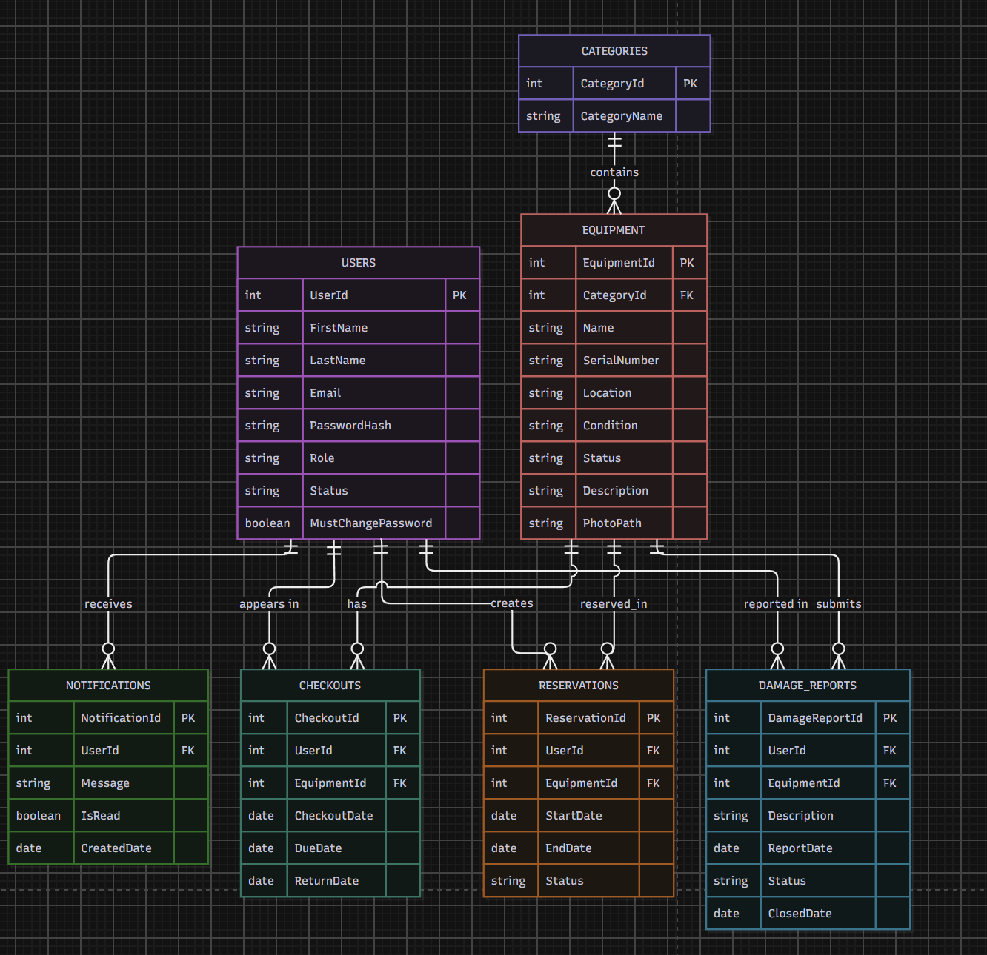
Figure 4. Equipment Inventory Management Database Entity Relationship Diagram
Equipment Checkout and Return
Equipment Checkout
When an Employee selects Check Out from an equipment details page, the server will first verify that the user is logged in and allowed to perform the checkout. The service will retrieve the equipment item and confirm that its current status is Available. It will also check the number of active checkouts for the Employee against the configured checkout limit. If the item is available and the Employee is under the limit, the system will calculate the due date, create the checkout record, change the equipment status to Checked Out, and save the changes as one database transaction.
After a successful checkout, the Employee will be directed to the My Equipment page where the item and its due date can be viewed. If the item is no longer available or the Employee has reached the checkout limit, the checkout will not be completed and the system will display a message explaining why.
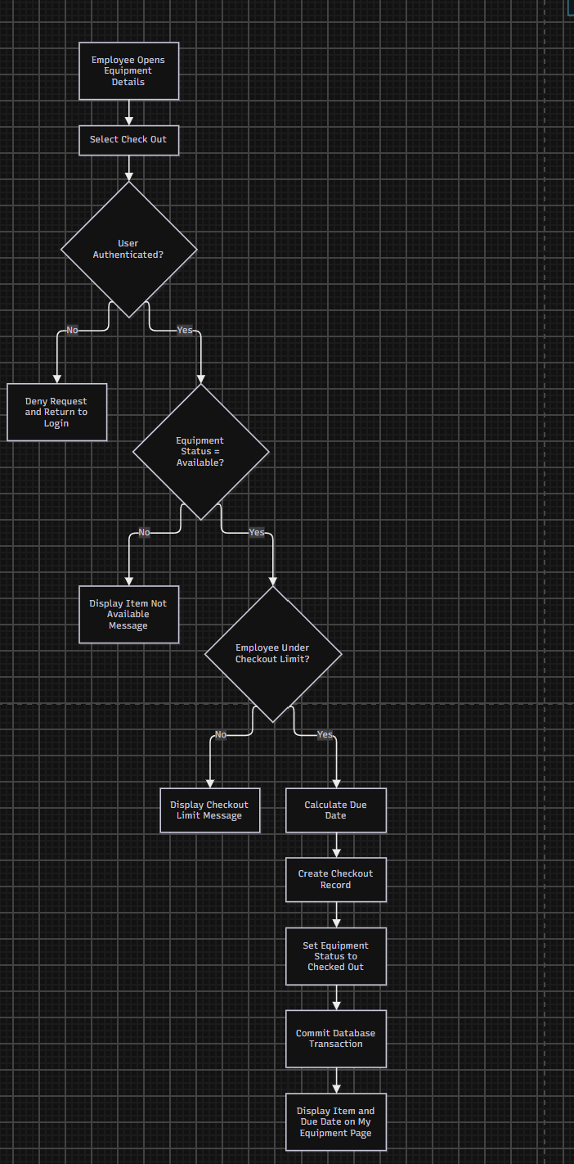
Figure 5. Equipment Checkout Flow
Equipment Return
When an Employee selects Return on the My Equipment page, the application will locate the active checkout record for that Employee and equipment item. The system will record the return date, change the equipment status back to Available, and save the changes. The checkout record will remain in the database so that the completed transaction continues to appear in the Employee and equipment history.
An Administrator will also be able to record a return on behalf of an Employee. The same return date and history information will be preserved regardless of which authorized user records the return.
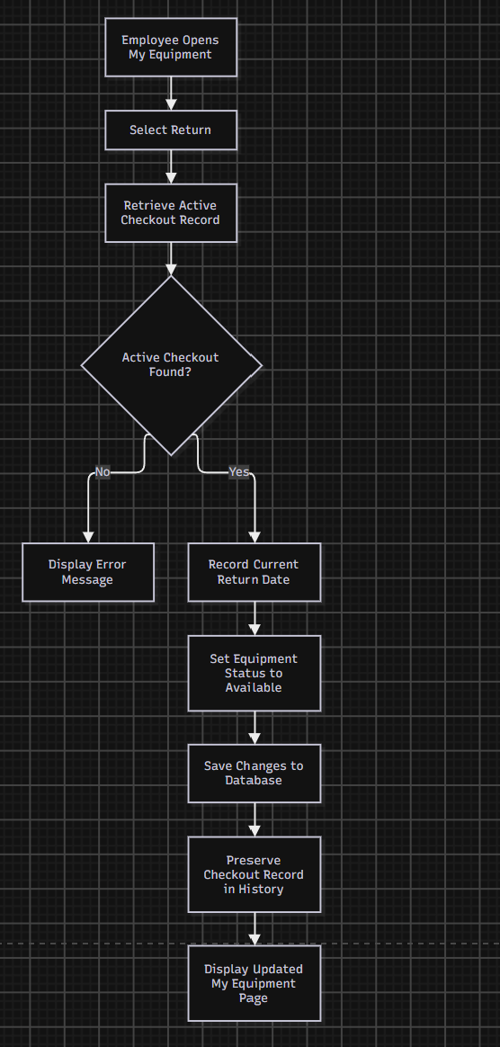
Figure 6. Equipment Return Flow
Equipment Management Design
Add and Edit Equipment
Administrators will manage equipment through Add Equipment and Edit Equipment forms. Required fields will include Name, Category, and Serial Number. The server will reject a new or edited record if the serial number is already assigned to another equipment item. Optional information such as location, condition, description, and photo can also be stored. When an edit is saved successfully, the user will return to the item details page with a confirmation message.
Equipment Status and Retirement
Equipment can use the statuses Available, Checked Out, Reserved, Under Repair, Lost, or Retired. Only equipment with an Available status can be checked out. Retirement will not delete the item. Instead, the status will be changed to Retired so that the item can no longer be checked out while its previous history stays in the database. A confirmation step will be used before an Administrator retires an item.
Categories, Photos, Search, and Filters
Administrators will be able to add and rename equipment categories. Category names will be checked so that duplicate names are not created. Equipment photos will accept JPG or PNG files up to 5 MB, and a placeholder image will be used when no photo is available. The Equipment List will support searching by equipment name or serial number and filtering by category and status. Search and filters can be used together, and Clear Filters will return the user to the full equipment list.
Account and User Management Design
Administrators create accounts through the Create Account form. The form collects First Name, Last Name, Email, Role, and Temporary Password. The server checks that the email is in a valid format and is not already used by another account. It also checks that the temporary password has at least 8 characters, including a letter and a number. The password is hashed before it is saved. The new Users record is created with an Active status and a flag that requires the password to be changed at first login.
When a user logs in, the authentication service looks up the account by email and compares the submitted password to the stored hash. It then checks the account status. Deactivated accounts and accounts still in Pending status are rejected with their own messages. If the "must change password" flag is set, the user is sent to the Change Password page, and every other page is blocked until a new password is saved. Once the new password is saved, the flag is cleared.
An Administrator can reset an Employee's password by assigning a new temporary password. This sets the same flag again. An Administrator can also change an account between Active and Deactivated. Deactivation only changes the status field. The user's checkout, reservation, and damage report records stay in the database. Self sign-up is a Low-priority backlog item. If it is built, it will use the same Users table: the request is saved with a Pending status, and an Administrator approves it (setting it to Active) or denies it from the User Management page.

Reservation Design
An Employee requests a reservation from an equipment details page by choosing a start date and an end date. The server checks that the start date is today or later, that the end date is on or after the start date, and that the item is not Retired. If these checks pass, it saves a Reservations record with a Pending status. The Employee is then taken to My Reservations, which lists each request with its item, date range, and status.
Administrators review Pending requests on the Reservations page. When an Administrator selects Approve, the service looks for any Approved reservation for the same item whose dates overlap the request. Two date ranges overlap when each range starts on or before the day the other one ends. If an overlap is found, the approval is blocked and the message "This request overlaps an existing reservation" is shown. Otherwise, the status is set to Approved. A Deny action sets the status to Denied. In both cases, the system creates a notification for the Employee in the same database transaction.
The Reserved status is calculated from the stored data rather than saved separately. While the current date falls within an Approved reservation's date range, the item is shown as Reserved and the Check Out button is disabled for everyone except the Employee who holds the reservation.

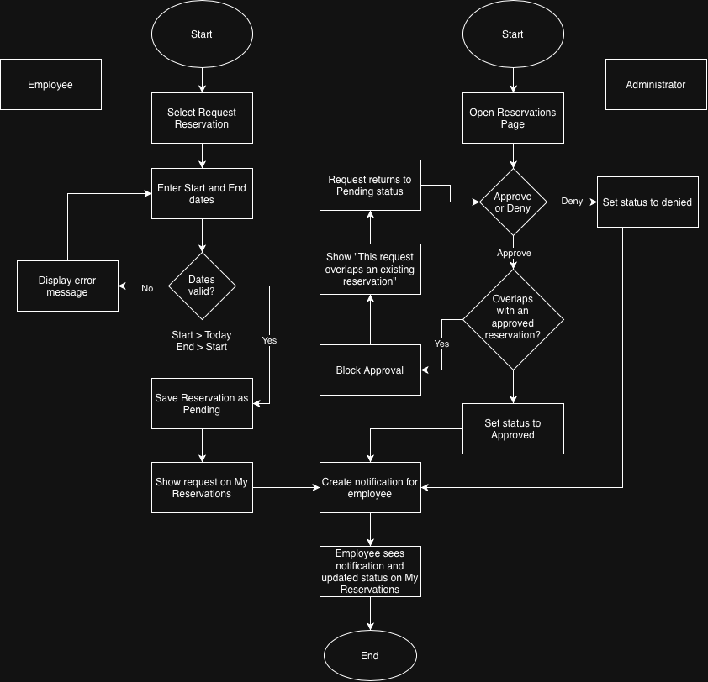

Figure 7. Reservation Request and Approval Flow

Damage Reports and Notifications
An Employee selects Report Damage on an equipment details page and enters a description between 10 and 500 characters. The server saves a DamageReports record with the item, the reporter, the report date, and an Open status. In the same transaction, it creates a notification for the Administrators. The item's status does not change automatically, so a single report cannot take equipment out of service without an Administrator reviewing it.
The Damage Reports page shows open reports with the item, reporter, date, and description. If an Administrator selects Mark Under Repair, the item's status is set to Under Repair, which also stops it from being checked out. Selecting Close Report sets the report to Closed and records the closing date. The item's status is then changed separately when it is ready to return to service.
All notifications are stored in the Notifications table with the user they belong to, the message, the date created, and a read or dismissed flag. Notifications are created when a reservation is approved or denied and when a damage report is submitted. After login, and on each page load, the shared layout shows the user's unread notifications in the message area until they are dismissed. The overdue reminder works differently. It is not stored as a notification. Instead, it is calculated when the Employee logs in from their active checkouts that are past due, so it disappears on its own once those items are returned. As required by the project scope, notifications appear on screen only, and no email is sent.

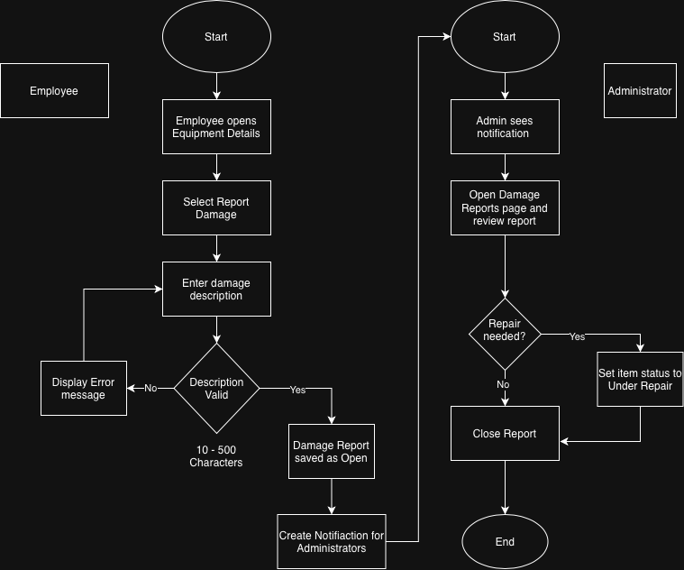
Figure 8. Damage Report and Notification Flow
Background Tasks
The application has very few true background tasks. Most time-based values are calculated when they are requested, which keeps the design simple and keeps the data from going out of date. Overdue status is calculated by comparing each active checkout's due date to the current date. This one calculation is used for the My Equipment highlight, the overdue reminder at login, the Overdue List, and the Dashboard's Overdue count. The Reserved status is calculated from Approved reservations and the current date in the same way. Dashboard counts are queried from the database each time the page loads, as FR-39 requires.
Session expiration is handled by the server's session management. Sessions are invalidated automatically after 30 minutes of inactivity. If the team later finds that calculating values on each request is too slow at larger data volumes, a scheduled job that runs once a day could save the overdue and reserved flags ahead of time. The current design does not require one.

Interfaces With Other Systems
The application has no outside system integrations. This matches the project scope, which excludes email, barcode or RFID hardware, GPS, purchasing, and accounting systems. Its interfaces are the web browser, the relational database, and file storage for equipment photos.
The browser talks to the server over HTTP. HTTPS should be used once the application is deployed, so that login credentials and session cookies are encrypted in transit. The server connects to the relational database through the repository layer using the database's standard driver. The connection settings are kept in a configuration file rather than written into the code.
Uploaded photos are checked for type and size, then saved to a storage folder on the server under a generated file name. Only the file reference is saved in the Equipment record. Printing uses the browser's built-in print function together with the print-friendly view, so no separate reporting tool is needed. The final hosting environment is still an open issue, as noted in the Open Technical Issues section.

Security Design
Authentication
Registered users will sign in with an email address and password. Passwords will not be stored in plain text. The application requirements call for salted password hashes such as BCrypt. When the user submits valid credentials, the application will create an authenticated session. The session will end when the user logs out and will also expire after 30 minutes of inactivity.
Authorization
The application will use role-based authorization for the Employee and Administrator roles. Employee users will not be allowed to access Administrator-only functions such as adding or retiring equipment, managing user accounts, approving reservations, or viewing administrative reports. The user interface can hide controls that do not apply to an Employee, but the server will still check the role for every protected request. This prevents a user from bypassing the interface and trying to open an Administrator page directly.
Input Validation and Error Handling
All important input will be validated on the server even when client-side validation is also used. Invalid data will be rejected before database changes are made. User-facing error messages will explain what needs to be corrected without displaying stack traces, database errors, or other internal details. This keeps the interface easier to understand and avoids exposing unnecessary technical information.
Nonfunctional Requirements and Verification
The nonfunctional requirements from Milestone 2 describe how the application should behave in areas such as security, performance, browser support, accessibility, and maintainability. The following table explains how each requirement can be checked during development and testing.
Requirement | Verification Method
NFR-1 - Password storage | Inspect stored account data and confirm that passwords are stored as salted hashes and never as readable plaintext.
NFR-2 - Session timeout | Log in, remain inactive for 30 minutes, and verify that the session expires and protected pages require authentication again.
NFR-3 - Role authorization | Log in as an Employee and attempt to directly open Administrator-only pages or actions. The server should deny the request.
NFR-4 - Server validation | Submit invalid form values, including attempts that bypass browser validation, and verify that the server rejects the data.
NFR-5 - Equipment List performance | Load and search/filter the Equipment List with up to 1,000 equipment records and verify that the page completes in under 3 seconds.
NFR-6 - Browser compatibility | Run the main Employee and Administrator workflows in current versions of Chrome, Edge, and Firefox.
NFR-7 - Small-screen layout | Test pages at a width of 360 pixels and verify that content remains readable without horizontal scrolling.
NFR-8 - Record retention | Deactivate a user and retire equipment, then verify that previous checkout and history records are still available.
NFR-9 - Checkout transaction | Attempt competing checkouts for the same equipment item and verify that only one checkout can be completed.
NFR-10 - User-friendly errors | Trigger invalid routes and application errors and verify that users see understandable messages instead of stack traces or database details.
NFR-11 - Accessibility | Verify that form fields have labels, images have alt text, and common pages can be navigated using the keyboard.
NFR-12 - Layered MVC structure | Review the project structure and confirm that controller, service, repository, and data responsibilities remain separated.
NFR-13 - Date consistency | Verify that application dates use the configured server time zone and display to users in MM/DD/YYYY format.
Open Technical Issues
Three project decisions from Milestone 2 are still open and should not be guessed at in the technical design. The default checkout period has not been finalized, the maximum number of active equipment checkouts allowed per Employee has not been finalized, and the final hosting or deployment location has not been selected. Until the team makes those decisions, the design will treat the checkout period and checkout limit as configurable values and will keep the deployment environment listed as TBD.
References
Grand Canyon University. (2020). CST-326 technical design document guidance [Course template].
Puckett, D., & Albecker, J. (2026). Software functional requirements document for Equipment Inventory Management Application [CST-326 Milestone 2].

